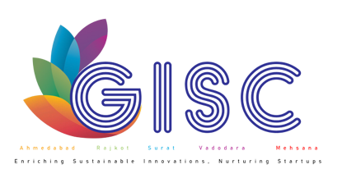

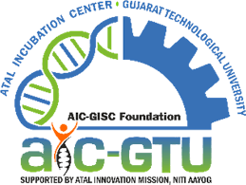

Report on
World creativity & Innovation Day Accelerating Innovation & Creativity - 2024
Date –April 19, 2024

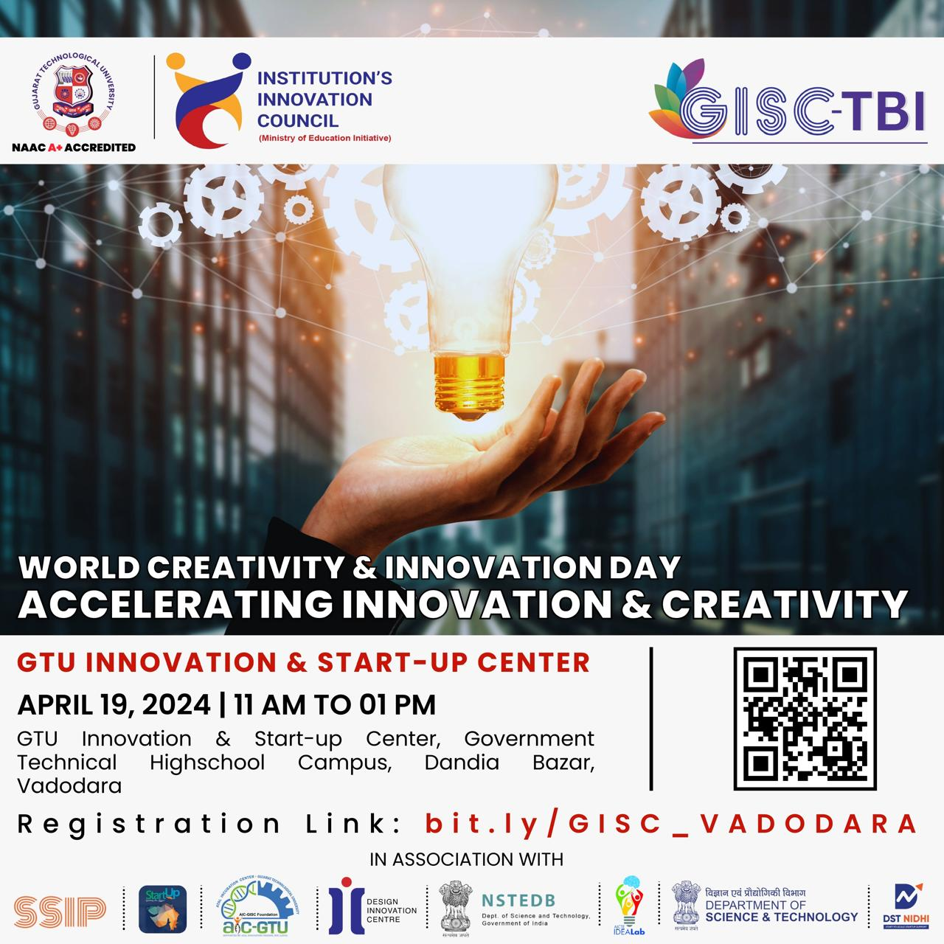

Venue
Dandia Bazar, Jambulet, GTU Innovation and Startup Center, Vadodara

About GIC:

GTU Innovation Council (GIC) has been designed to establish close bonding between industries, entrepreneurs, faculty members and students to make research and development at the University, relevant to the needs of industries at national and international levels. It helps to create a culture of design, new and products augmentation and processes in the arena of industries. GTU Innovation Council as an innovation campaign has started strategic steps to establish a close and continuing inter-action for the students in all the undergraduate and postgraduate courses. GTU Innovation Council is one of the elite organizations of the nation for cultivating multilayer innovation ecosystem. Through the efforts for creating culture of innovation and entrepreneurship in 8 years, an aura of developing the ecosystem across the state was conceptualized. The pilot projects and efforts have ideated many policies which have helped to change and shape up innovation and entrepreneurial mind-set of students. GIC is pioneering more than 12 initiatives in 8 sectors of the council.

GTU Innovation Council provide support to Innovators for various grant along with Networking with Mentors, Strategies for market Traction and other allied support to scale up the Start-ups.

About the Event:

GTU Innovation & Startup Center Vadodara embraced World Creativity and Innovation Day on April 19, 2024! Two dynamic sessions captivated a total of 40 students, immersing them in essential innovation principles to kindle their creativity. Through interactive discussions and engaging activities, participants explored the depths of innovation, fostering an environment ripe for inspiration. The event not only celebrated the spirit of innovation but also cultivated a mindset geared towards inventive thinking, empowering the youth to become catalysts of change in their respective fields.

Glimpse of the Event:

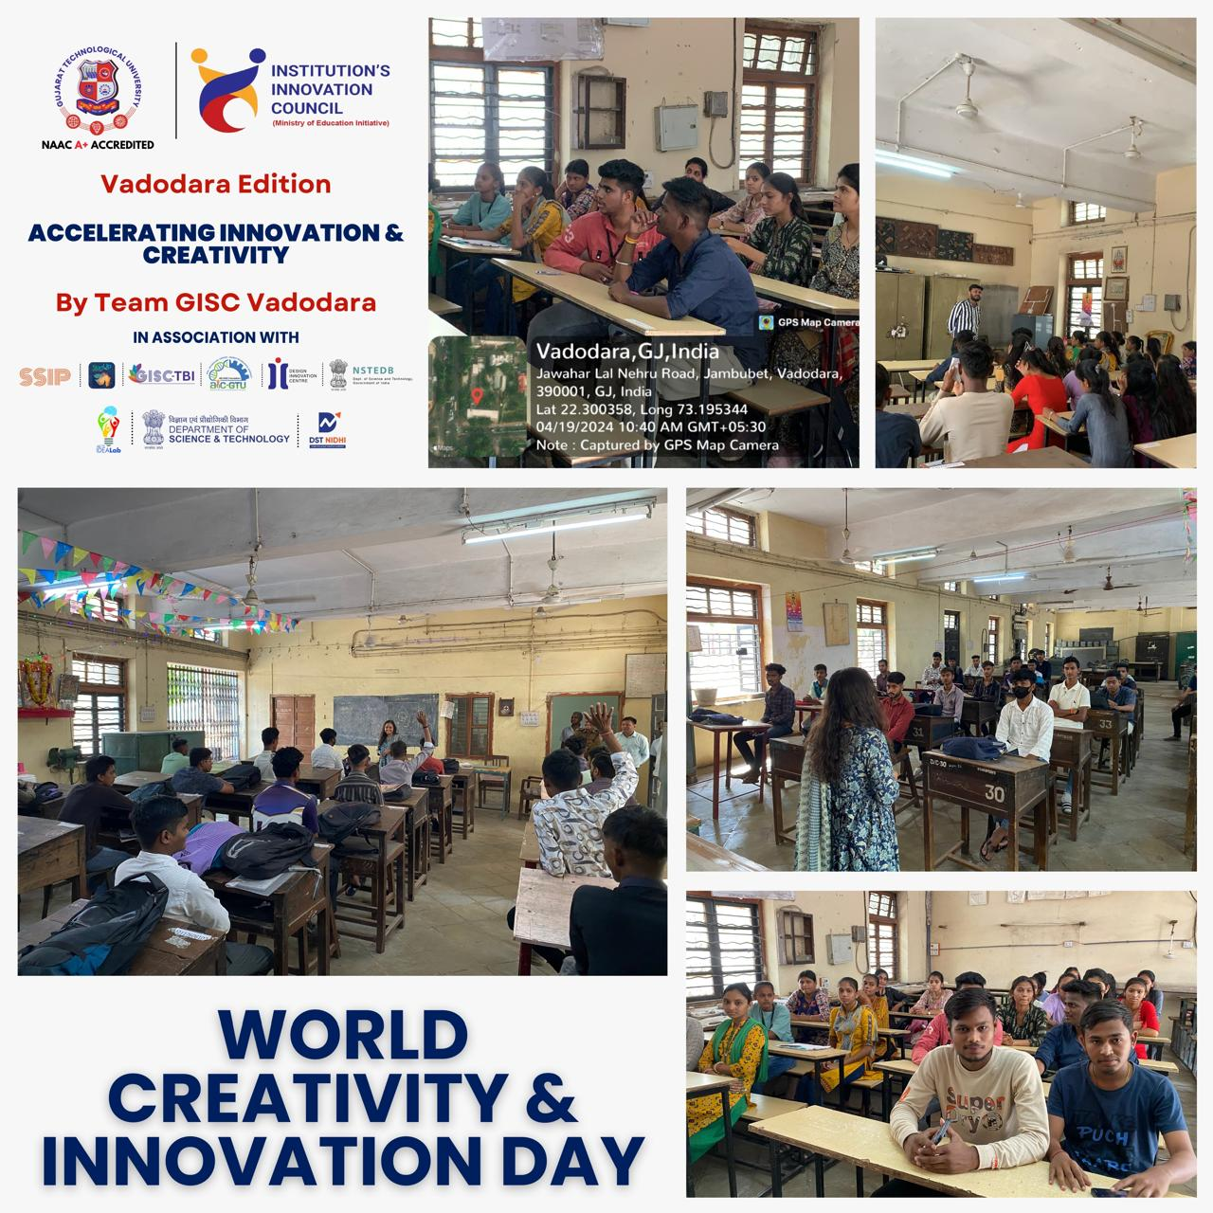

Attendance of the Event:

